**Web Application**

**Definition**

A web application is a computer program that utilizes web browsers and web technology to perform tasks over the Internet.

**Overview**

Millions of businesses use the Internet as a cost-effective communications channel. It lets them exchange information with their target market and make fast, secure transactions. However, effective engagement is only possible when the business is able to capture and store all the necessary data, and have a means of processing this information and presenting the results to the user.

Web applications use a combination of server-side scripts (PHP and ASP) to handle the storage and retrieval of the information, and client-side scripts (JavaScript and HTML) to present information to users. This allows users to interact with the company using online forms, content management systems, shopping carts and more. In addition, the applications allow employees to create documents, share information, collaborate on projects, and work on common documents regardless of location or device.

**How a web application works**

Web applications are usually coded in browser-supported language such as JavaScript and HTML as these languages rely on the browser to render the program executable. Some of the applications are dynamic, requiring server-side processing. Others are completely static with no processing required at the server.

The web application requires a web server to manage requests from the client, an application server to perform the tasks requested, and, sometimes, a database to store the information. Application server technology ranges from ASP.NET, ASP and ColdFusion, to PHP and JSP.

Here's what a typical web application flow looks like:

User triggers a request to the web server over the Internet, either through a web browser or the application’s user interface

Web server forwards this request to the appropriate web application server

Web application server performs the requested task – such as querying the database or processing the data – then generates the results of the requested data

Web application server sends results to the web server with the requested information or processed data

Web server responds back to the client with the requested information that then appears on the user’s display

**Example of a web application**

Web applications include online forms, shopping carts, word processors, spreadsheets, video and photo editing, file conversion, file scanning, and email programs such as Gmail, Yahoo and AOL. Popular applications include Google Apps and Microsoft 365.

Google Apps for Work has Gmail, Google Docs, Google Sheets, Google Slides, online storage and more. Other functionalities include online sharing of documents and calendars. This lets all team members access the same version of a document simultaneously.

**Benefits of a web application**

Web applications run on multiple platforms regardless of OS or device as long as the browser is compatible

All users access the same version, eliminating any compatibility issues

They are not installed on the hard drive, thus eliminating space limitations

They reduce software piracy in subscription-based web applications (i.e. SaaS)

They reduce costs for both the business and end user as there is less support and maintenance required by the business and lower requirements for the end user’s computer

Web applications can be simple consisting of only **static web pages** or they can be **dynamic** and interactive.

Static web pages are stored in the file system of web server usually displays the same information to all visitors. Whereas dynamic pages are constructed by a program that produce the HTML. This type of web application provide individual information to the user and let them personalize the content according to their preferences.

**How the (static) web work?**

We already know that to open a web page we enter URL or click on link and web browser displays web page that we request. Let's discuss the steps that happen behind the scene.

The user enters a URL in the browser.

The browser sends a request to the web server over the internet.

Web Server examines the request and based on the request server finds the requested page already stored in its local drive.

Web Server sends the response to the web client (browser).

Browser gets the HTML and renders it into a display for the user.

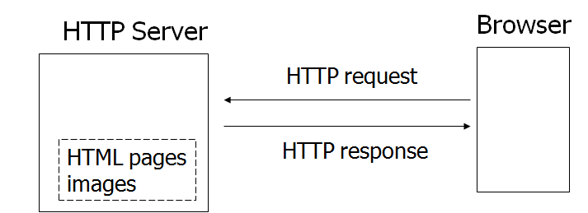

The request and response communications over the internet between client and server are held using the HTTP protocol. That's why the server is often called as HTTP server. When a server answers a request, the server usually sends some type of content to the browser so that the browser can display it. Servers often send the browser a set of instructions written in HTML. HTTP uses URLs (Uniform Resource Locator) to identify data on the Internet.

**Dynamic Web Content**

Dynamic web content is the content that changes with every user request. This type of web application let the users personalize the content according to their preferences.

To build such a powerful web app, you need Java technologies, like servlet and JSP. Web Server is mostly designed to serve static HTML content. For this type of app, web server needed a servlet plugin that can communicate with or build dynamic pages.

Servlet plugin is also called as servlet container or web container.

Servlets were Java's first server-side web technology. A Servlet is an ordinary Java class that implements a special Servlet interface. This class is then deployed in a Servlet container. The servlet container is connected to a web server. When an HTTP request arrives at the web server which should be handled by a servlet, the web server forwards the request to the servlet container. The servlet container then forwards the request to the servlet that is to handle the request.

Today most servlet containers come with built-in web servers, so you do not often make the distinction between a Java web server and a Java servlet container. Examples of Java web servers with servlet containers are Apache Tomcat, GlassFish, Jetty, JBoss etc.

**Conclusion**

Increased Internet usage among companies and individuals has influenced the way businesses are run. This has led to the widespread adoption of web applications as companies shift from traditional models to cloud-based and grid models. Web applications give businesses the ability to streamline their operations, increase efficiency, and reduce costs.

These online apps such as email clients, word processors, spreadsheets, and other programs provide the same functionality as the desktop versions. However, they have an added advantage of working across multiple platforms, having a broader reach, and being easily accessible from anywhere.